Image Trace in Illustrator
Creating a graphic Image from a Photograph
Commercial Design

Image Trace in Adobe Illustrator lets you convert raster images (Photoshop) to editable vectors using a new tracing engine introduced in Illustrator CS6.
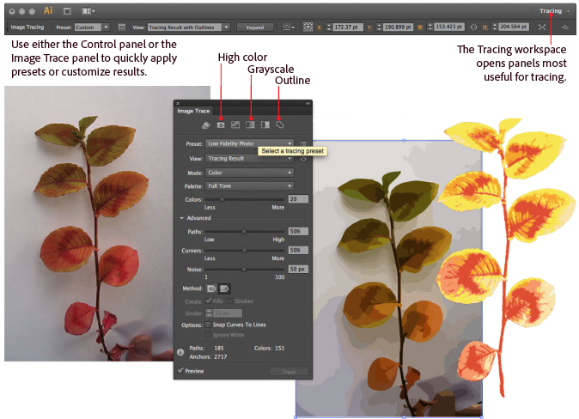
Introduction
Image Trace and Live Trace convert images to vectors (editable line art) and feature presets for easily creating various effects. This tutorial and guide covers how to use most of the new sliders and checkboxes, and includes a brief overview of the presets. Discover the ease of use of Image Trace by exploring these sections:
Part 1: Orientation: Anatomy of the Image Trace panel
- Presets
- View
- Mode
- Palette
- Colors
Part 2: Overview: Quick start-to-finish trace using presets
- Place an image
- Choose among presets
- Expand the tracing
Part 3: In Depth: Colors with palette selection
- Limited palette
- Full Tone palette
- Automatic palette
- Document Library palette
- Mode menu
Part 4: In Depth: Assigning pixels to shapes
- Pixel assignment
- Noise slider
- Strokes and Fills
Part 5: In Depth: Precise paths with curve fitting
- The Paths slider
- The Corners slider
- The Snap to Lines checkbox
- Abutting versus Overlapping paths
Part 6: Wrapping up

Part 1: Orientation: Anatomy of the Image Trace panel
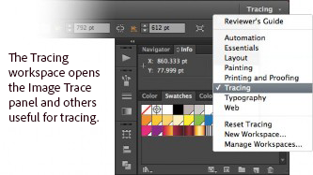
Here is a brief tour of the Image Trace panel. Begin by creating a new document in Illustrator. Switch to the Tracing workspace (WINDOW-WORKSPACE- TRACING) so that you can see the Image Trace and other relevant panels.

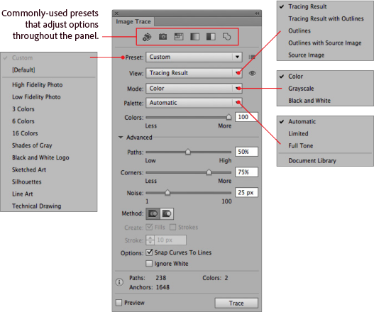
Place an image for tracing into your Illustrator artboard. (FILE-PLACE) When the image is selected, you can see that the options in the Image Trace panel become available. At the top of the panel are the basic options; you can expose additional options by turning the triangle next to the Advanced label.
The Tracing workspace opens the Image Trace panel and others particularly useful for tracing.
- Presets
The icons located across the top of the panel are shortcuts named according to popular workflows. Choosing one of these will set all the variables needed to produce that related tracing result. Additional presets are accessible in the top drop-down menu.
- View
Beneath the Presets menu is the View drop-down menu. This controls what you see after tracing.
- Mode
The Mode drop-down menu provides choices that define basic color versus grayscale modes for your traced artwork.
- Palette
The Palette menu determines how colors will be chosen for the output artwork. These important options will be discussed in detail later in this document, but for now here are brief descriptions:
Automatic—automatically switches between limited palette and full tone for the tracing, depending on the input image
Limited—uses a small set of colors for the tracing palette
Full Tone—best for photos, creates photorealistic artwork
Document Library—uses an existing color group for the tracing palette
- Colors
The Colors slider generates slightly different results depending on the value selected for Mode, but in all cases the traced artwork gets more complicated as the slider is moved from left to right.

Part 2: Overview: Quick start-to-finish trace using presets
Here is a quick way to achieve a great tracing by taking advantage of the presets in Image Trace.

- Place an image
In the previous section of this tutorial you may have already completed this step, but to get started, create a new document in Illustrator and place the image that you wish to trace in the document. Select the image and check that the Image Trace panel is showing.
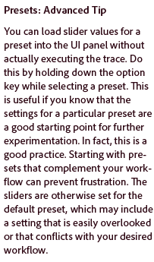
- Choose among presets
The row of icons across the top of the Image Trace panel are shortcuts that set the values of all the other sliders to achieve conversion for pre-determined workflow. Here are descriptions of the icons and their effects from left to right:
Auto Color—creates a posterized image from photo or artwork.
High Color—creates photorealistic artwork of high fidelity.
Low Color—creates simplified photorealistic artwork.
Grayscale—traces the artwork to shades of gray.
Black and White—simplifies the image to black-and-white artwork.

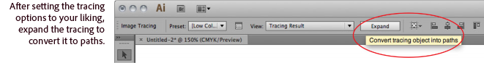
- Expand the tracing
To finish your quick trace, choose the Expand button in the Control panel at the top of your workspace. Note that when you do so, your placed image is replaced by your new vector objects.

Part 3: In Depth: Colors with palette selection
Now that you’ve seen the basics, here are details that you can use to refine your tracing and get exactly the effect you want. There are three fundamental behind-the-scenes steps to convert an image into vector artwork. The first is choosing a palette of colors for the traced artwork.
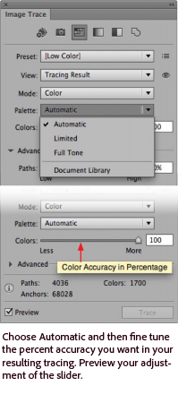
Under the hood, Image Trace can choose among four different ways to select colors for the tracing palette. They correspond to the four options you see in the Palette pull down menu. These options determine the number of colors allowed in your traced artwork and how they are chosen from the source image.
- Automatic palette selection
Automatic does the choosing for you. It analyzes your image, and in the case of a photo, generally using a palette that is full tone to create a high-fidelity rendering. If Image Trace detects a fewer colors in the image, it will do a limited palette tracing.
When you select Automatic for your palette, you can adjust the color accuracy setting. The Colors slider shows a number that indicates your trade-off between vector simplicity and accuracy in the tracing. The value 0 means simplified at the expense of accuracy and 100 means accurate, or photorealistic, at the expense of simplicity.
Summary: Automatic is a good starting setting as it will generally get the number of colors right off the bat. Automatic can be a better choice than Limited if you want to reduce the number of colors in a photo.
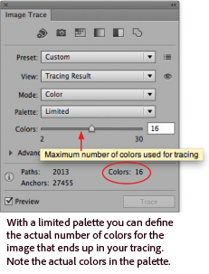
- Limited palette selection
Limited allows fewer colors in the palette. In cases where there are fewer colors in the image than the maximum, then the number of distinct colors in the image are used.

Where there are more colors in the image than the maximum, Image Trace uses two strategies to select colors for the palette:
  - Chooses colors that have many similar colors, close together.
  - Chooses colors that take up the most area, leaving out less-represented colors.
You can use the Color slider to further reduce the colors selected. However, in cases where the number of colors selected by the slider is less that the number of colors in the image or the image is a photo with a lot of gradually changing colors, the result may seem drab. Brighter colors that occur in small areas may be omitted.
Summary: Limited is a good choice for tracing artwork with fewer colors, but sometimes not a good choice for photos.
- Full Tone palette selection
Full Tone determines the color palette by grouping adjacent pixels of similar color together in your image to create each filled region in the result.
The Color slider determines the variability of the pixels that make up each of those fill regions. When the slider is to the right, that variability is smaller, resulting in more paths defined by smaller areas of color. When the slider is to the left, the fill areas are fewer and larger. The color chosen for each fill is simply the color most similar to all the pixels within the fill area.
Summary: Full tone works great for photos and results in the best color fidelity. If you try to use Full Tone with an image that has few colors, forcing the slider to the right can cause artifacts to be picked up as colors — you may get many tiny fills that look like noise.
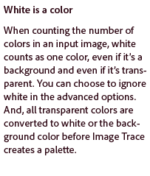
- Document Library palette selection
Document Library allows you to define the exact colors you want in your traced artwork. You can load any library of colors into your document via your Swatches panel and it will appear here as a choice for your tracing palette.
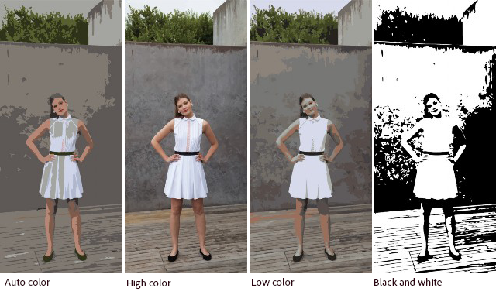
Each color in your input image will be mapped to the closest match in the color group you have selected. This sometimes produces unexpected results, especially where colors bleed into each other. By adjusting the noise slider you can sometimes control these artifacts.

Summary: Document Library is useful if you wish to precisely define the colors used in your tracing.
- Mode menu
The palette choices are available when you are in the Color Mode. If you choose Grayscale or Black and White, your choice of palette menu is removed, but also reveals sliders that allow you to control the way the tones are determined. When you choose Grayscale, the Full, Limited, and Automatic parameters apply as you use the Grays slider. When you choose Black and White, the Threshold slider allows you to adjust the black-to-white transition.

Try it
In your Illustrator document, select the image you have placed for tracing and in the Image Trace panel, ensure that Preview is checked. Set the Mode to Color, and choose the each of the Palette options in turn.
Note: that the resolution of your placed image determines the speed of the tracing (larger the resolution, the longer it takes to render- So you may open your image first in Photoshop and decrease the Image size to around 5x7 and 72 dpi for a faster ).

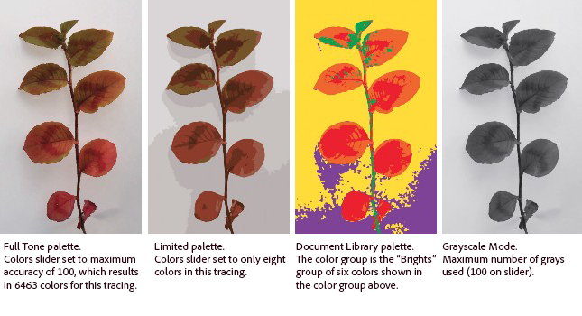
Your Assignment:
Choose a Photograph or Realistic Drawing to turn into a Graphic Image (preferably one you have taken- whether from your phone or a camera). Using the Live Trace Feature in Adobe Illustrator, Create 4 different Graphic Represents using various tracing presets. Use the guidelines below to help you
  - Full Tone Palette- High Color
  - Limited Palette- 6 or less colors
  - Greyscale or Black and White (whichever yields better results)
  - Your choice _____________________ (write what you did on the line)

Place all together next to each other and labeled in one document and then Export them as a .jpg from Illustrator and email to me etonon@psd202.org. You will turn this in by then of the period tomorrow with this sheet to be graded.

4- Excellent 3- Proficient 2- Beginning 1- Needs Improvement
  - Full Tone Palette- Auto Color ___/4pts
  - Limited Palette- 6 or less colors ___/4pts
  - Black and White ___/4pts
  - Your choice ___/4pts Total ___/16 pts
A=14-16pts B= 12-13pts C= 10-11pts D= 8-9pts

